Area of Circle
BY-
NAME- ASHMIT UPADHYAY
SECTION- C1
PRN- 25070521129

2. Pseudocode
- START
- READ the input value from the user and convert it to a floating-point number.
- STORE the value in a variable named radius.
- DEFINE a constant variable pi and assign it the value 3.14.
- CALCULATE the area using the formula: .
- FORMAT the resulting area to 4 decimal places.
- PRINT the formatted area.
- END

3. Flowchart
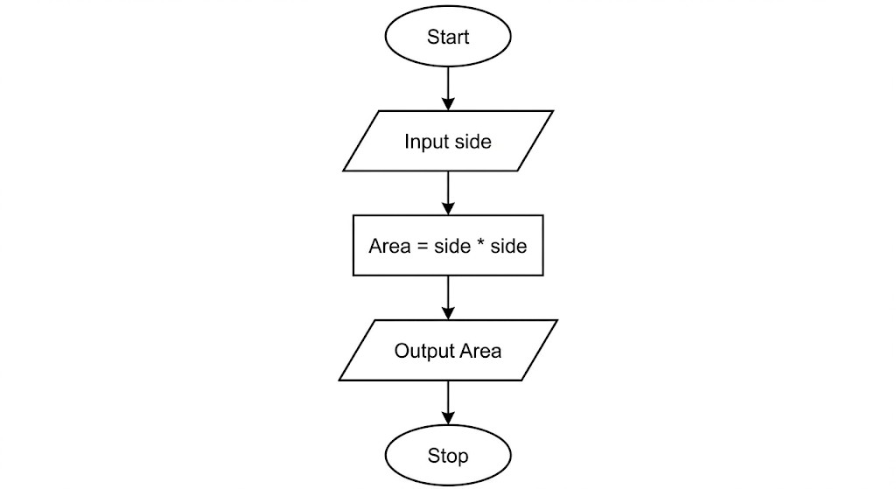

4. Python Program
# Program to calculate the area of a circle
# Input: Radius as a float
# Output: Area formatted to 4 decimal places

# Taking input from the user
radius = float(input())

# Constant value of Pi
pi = 3.14

# Calculating area
area = pi * radius * radius

# Displaying the result formatted to 4 decimal places print(f"{area:.4f}")

5. Experiment Screenshot
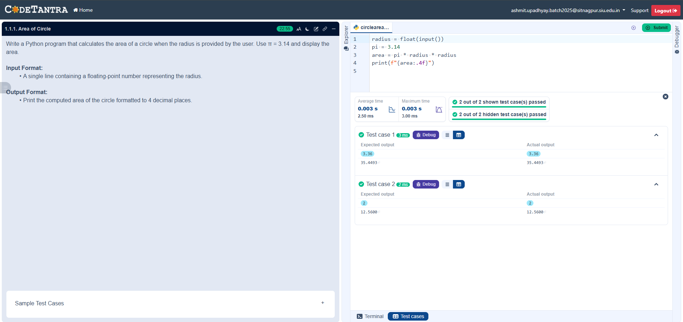

1.1.2. Area of Rectangle
BY-
NAME- ASHMIT UPADHYAY
SECTION – C1
PRN- 25070521129

2. Pseudocode
- START
- READ the first input value and store it as a float in the variable length.
- READ the second input value and store it as a float in the variable width.
- CALCULATE the area by multiplying length and width.
- STORE the result in the variable area.
- FORMAT the value of area to 2 decimal places.
- PRINT the formatted result.
- END

3. Flowchart
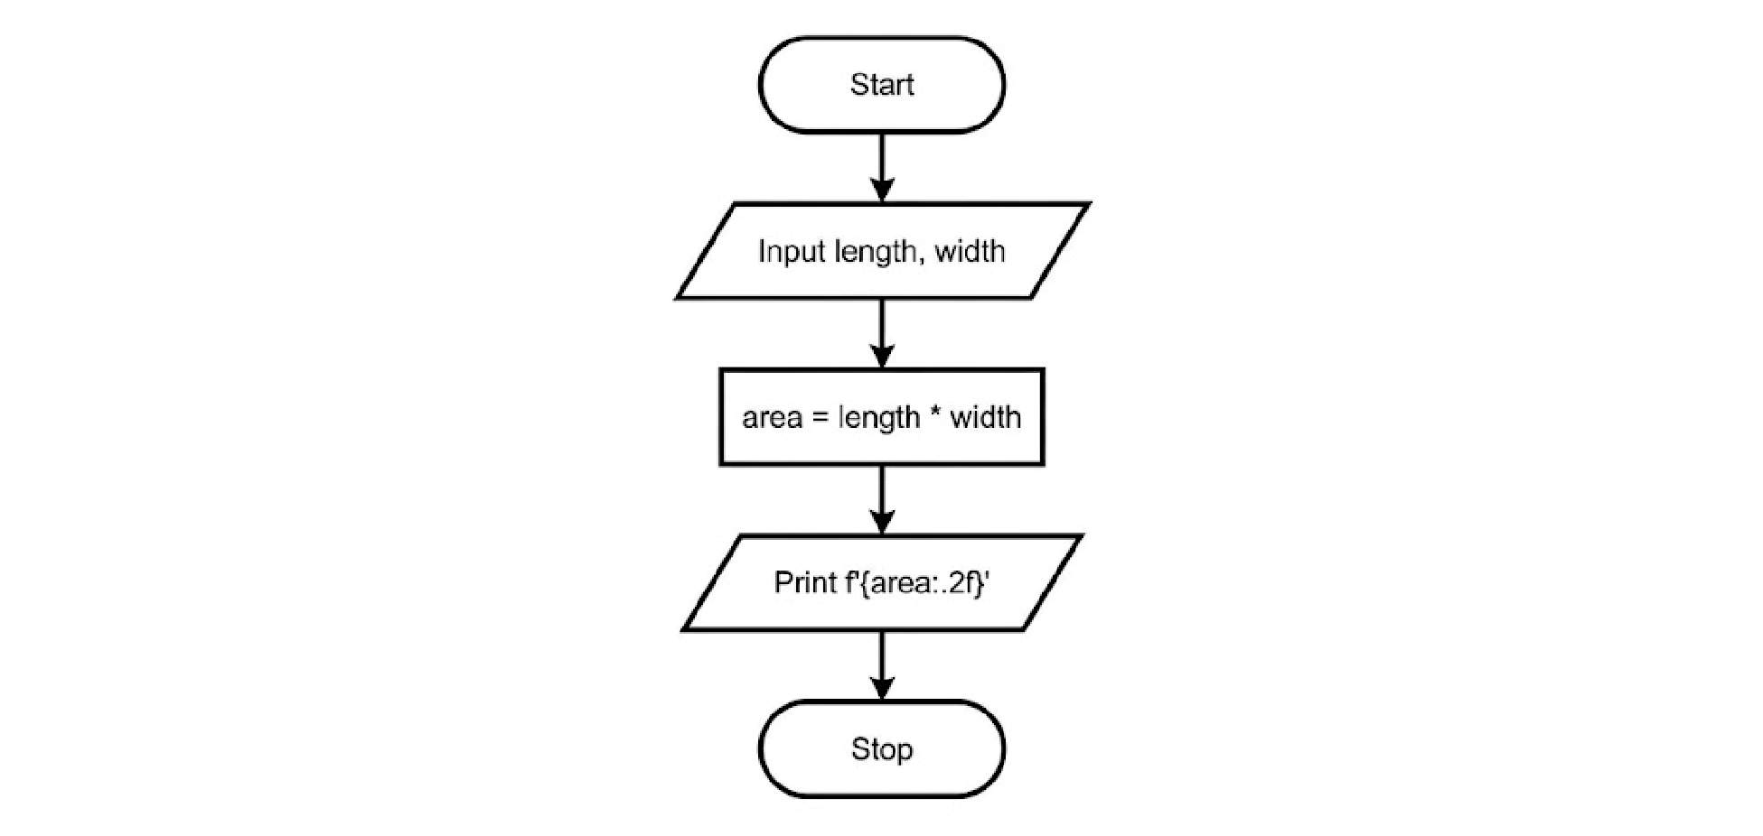

4. Python Program
# Program to calculate the area of a rectangle
# Input: Length and Width as floats
# Output: Area formatted to 2 decimal places

# Taking inputs from the user length = float(input())
width = float(input())

# Calculating area
area = length * width

# Displaying the result formatted to 2 decimal places print(f"{area:.2f}")

5. Experiment Screenshot
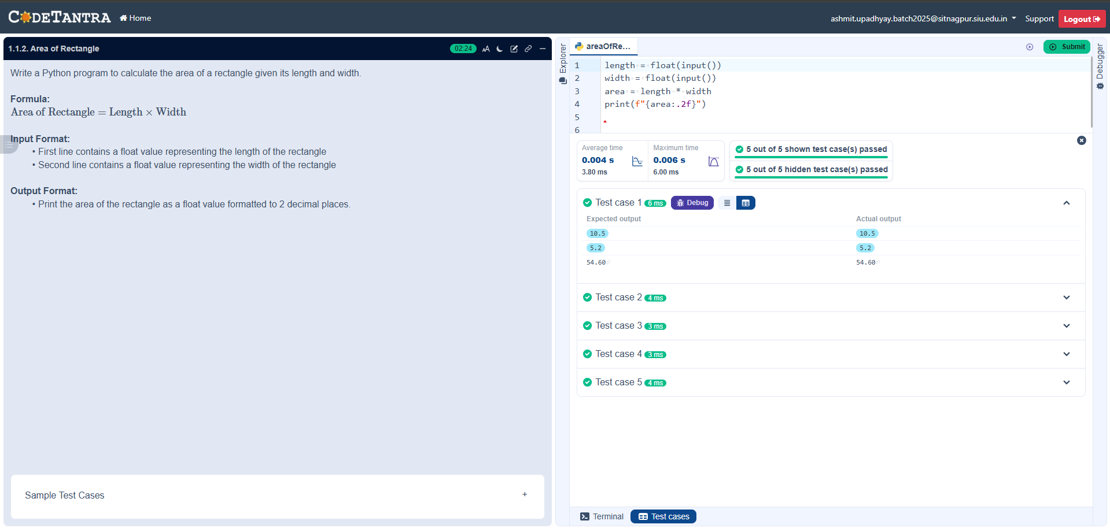

1.1.2 Calculate Area of the Square
BY-
NAME- ASHMIT UPADHYAY
SECTION – C1
PRN- 25070521129

2. Pseudocode
- START
- READ the input value from the user and convert it to an integer.
- STORE this value in the variable side_length.
- CALCULATE the area by multiplying side_length by itself (side_length * side_length).
- STORE the result in the variable area.
- PRINT the value of area.
- END

3. Flowchart
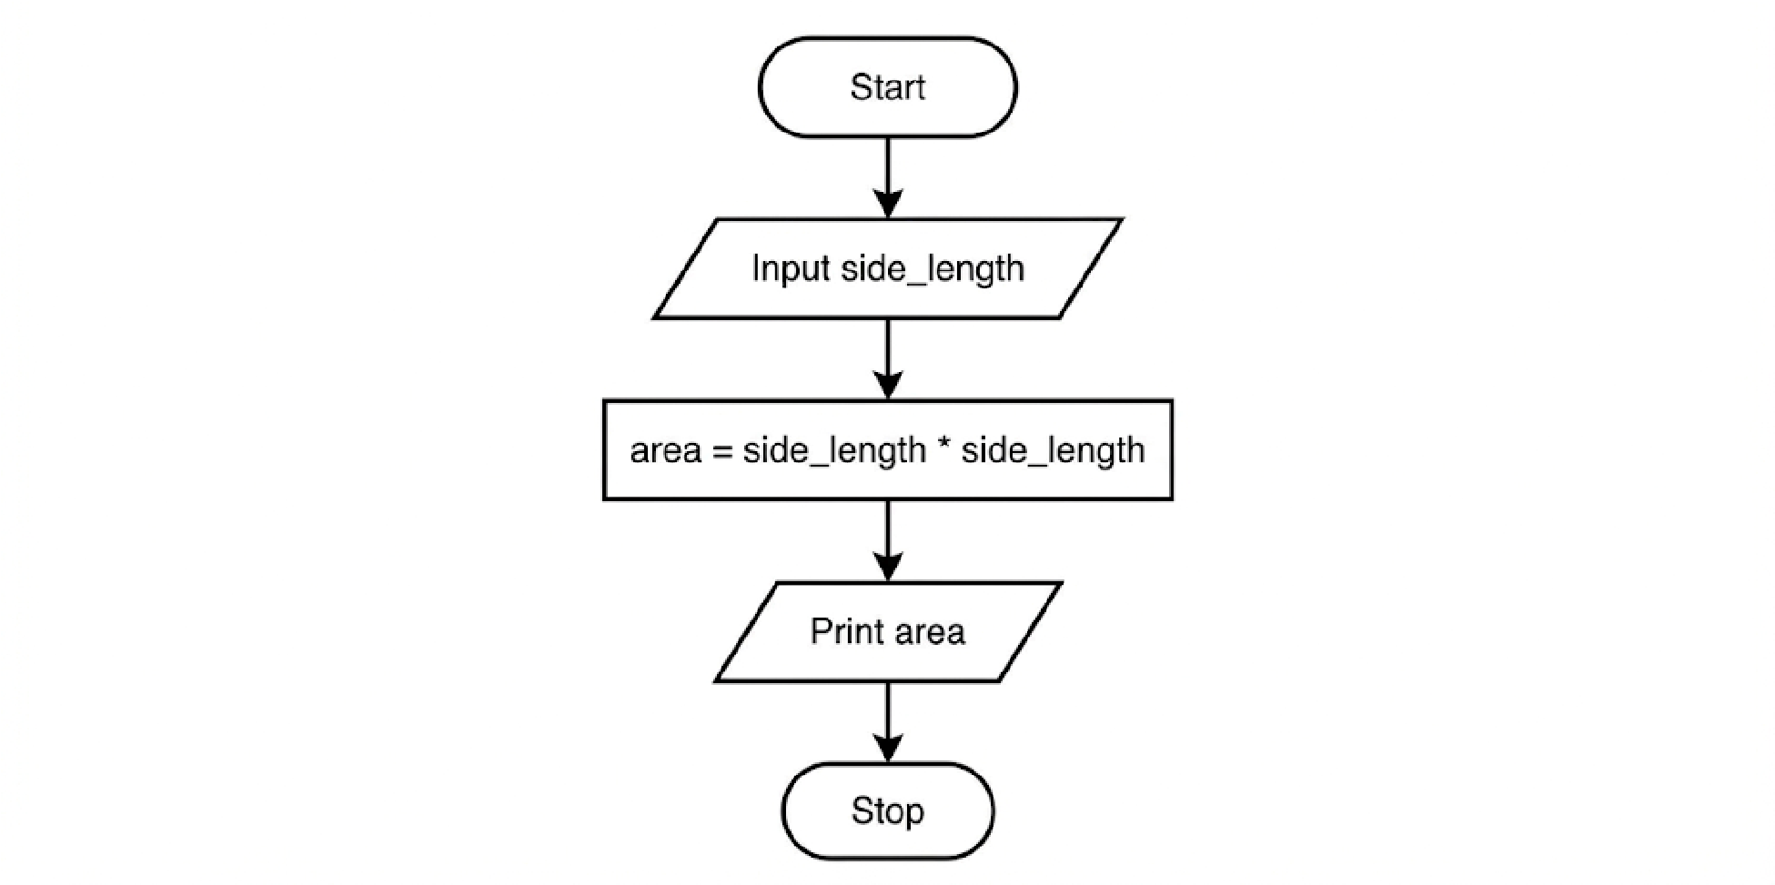

4. Python Program
# Program to calculate the area of a square
# Inpt: side_length as an integer

Output: area as an integer

# Taking input from the user
side_length = int(input())

# Calculating area (side * side)
area = side_length * side_length

# Displaying the result print(area)

5. Experiment Screenshot
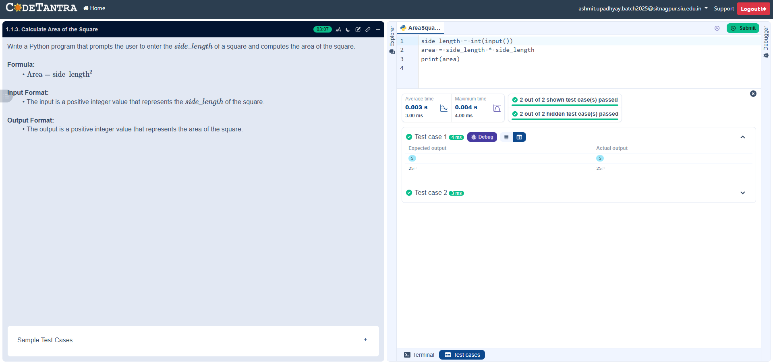

1.1.4. Area of Triangle
BY-
NAME- ASHMIT UPADHYAY
SECTION – C1
PRN- 25070521129

2. Pseudocode
- START
- READ the first input value and store it as a float in the variable base.
- READ the second input value and store it as a float in the variable height.
- CALCULATE the area using the formula: 0.5 * base * height.
- STORE the result in the variable area.
- FORMAT the result to show 2 decimal places.
- PRINT the formatted area.
- END

3. Flowchart
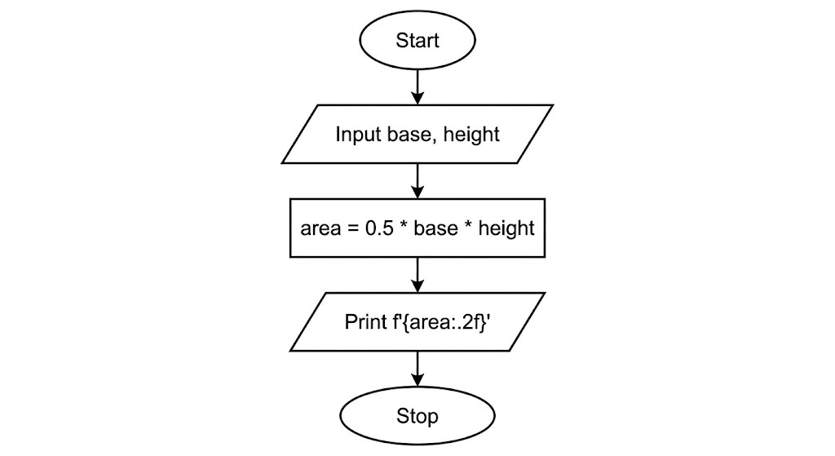

4. Python Program
# Program to calculate the area of a triangle
Input: Base and Height as float values
# Output: Area formatted to two decimal places

# Taking inputs from user base = float(input())
height = float(input())

# Calculating the area
area = 0.5 * base * height

# Displaying the output formatted to 2 decimal places print(f"{area:.2f}")

5. Experiment Screenshot
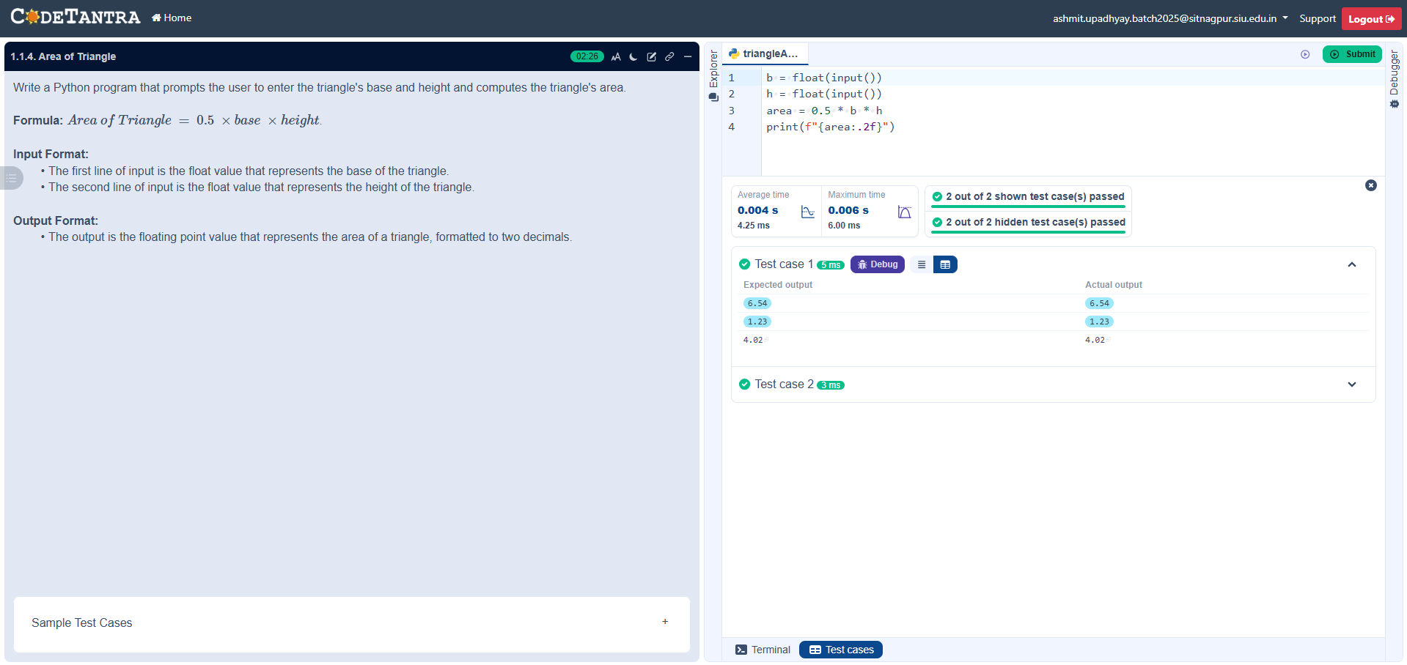

1.1.5. Student Pass or Fail Status
BY-
NAME- ASHMIT UPADHYAY
SECTION – C1
PRN- 25070521129

2. Pseudocode
- START
- READ the input value from the user and convert it to an integer.
- STORE the value in the variable marks.
- IF marks is greater than or equal to 40:
  - PRINT "Pass"
- ELSE:
  - PRINT "Fail"
- END

3. Flowchart
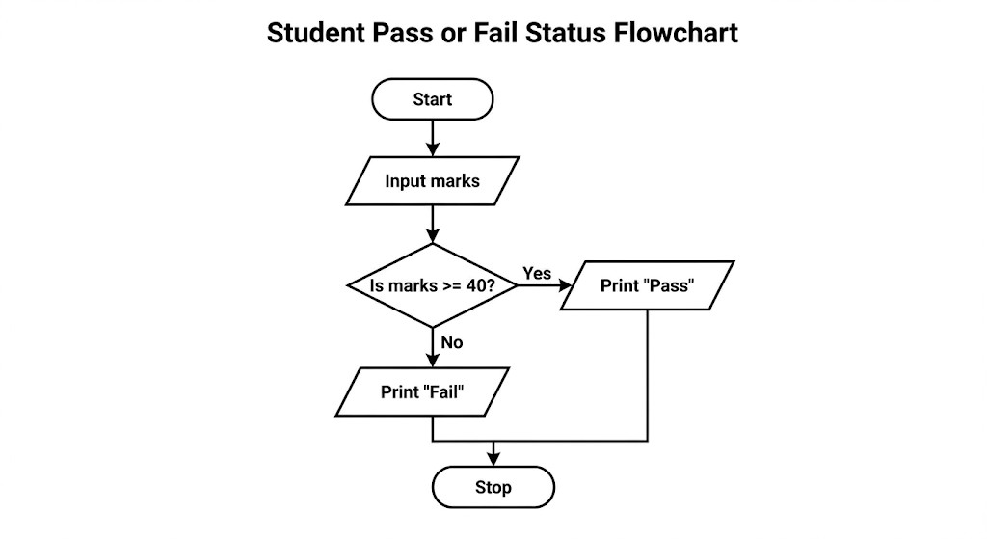

4. Python Program
# Program to determine student pass/fail status
# Input: marks as an integer
Output: "Pass" or "Fail" based on criteria

# Taking marks as input
marks = int(input())

# Conditional check for passing criteria if marks >= 40: print("Pass") else:
print("Fail")

5. Experiment Screenshot
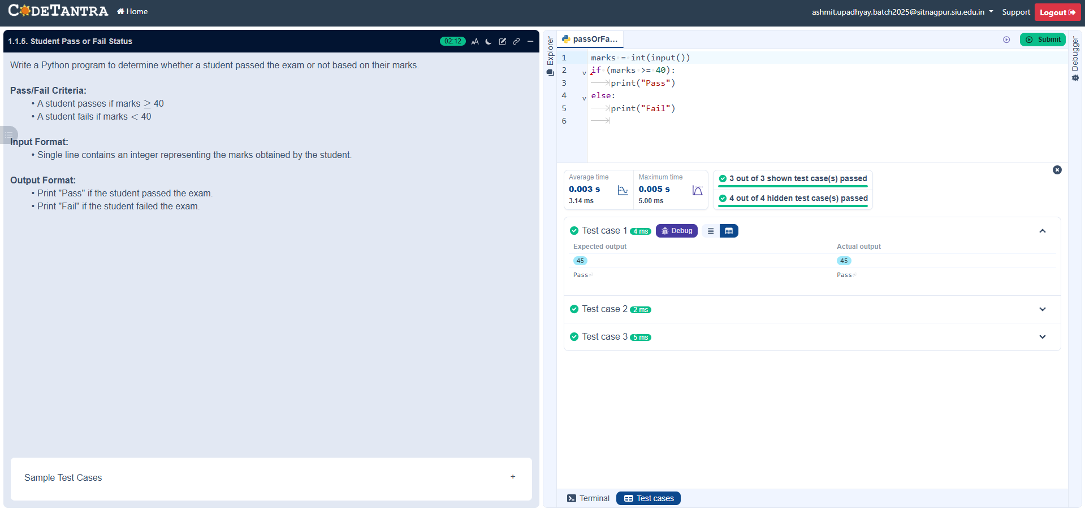

Experiment - 2.1.1. Roots of a Quadratic Equation
BY-
NAME- ASHMIT UPADHYAY
SECTION – C1
PRN- 25070521129
.

2. Pseudocode
- START
- READ three space-separated integers a, b, and c.
- CALCULATE the discriminant: .
- IF
:

○

Calculate

○

Calculate

  - PRINT "root1 = [value]" and "root2 = [value]" formatted to 2 decimal places.
- ELSE IF
  - Calculate
:

○ PRINT "root1 = root2 = [value]" formatted to 2 decimal places.
- ELSE (if ):
  - PRINT "Roots are imaginary".
- END

3. Flowchart
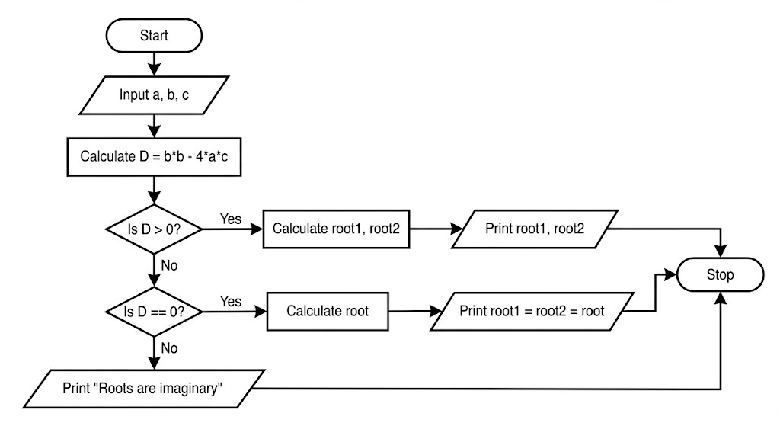

4. Python Program
# Program to find the roots of a quadratic equation
# Input: Space-separated coefficients a, b, and c
# Output: Roots formatted to 2 decimal places or nature of roots

import math

# Taking coefficients as input
a, b, c = map(int, input().split())

# Calculating the discriminant
D = b*b - 4*a*c

if D > 0:
# Real and different roots sqrt_D = D ** 0.5 root1 = (-b + sqrt_D) / (2 * a) root2 = (-b - sqrt_D) / (2 * a) print(f"root1 = {root1:.2f}")
print(f"root2 = {root2:.2f}")

elif D == 0:
# Real and same roots root = -b / (2 * a)
print(f"root1 = root2 = {root:.2f}")

else:
# Imaginary roots
print("Roots are imaginary")

5. Experiment Screenshot
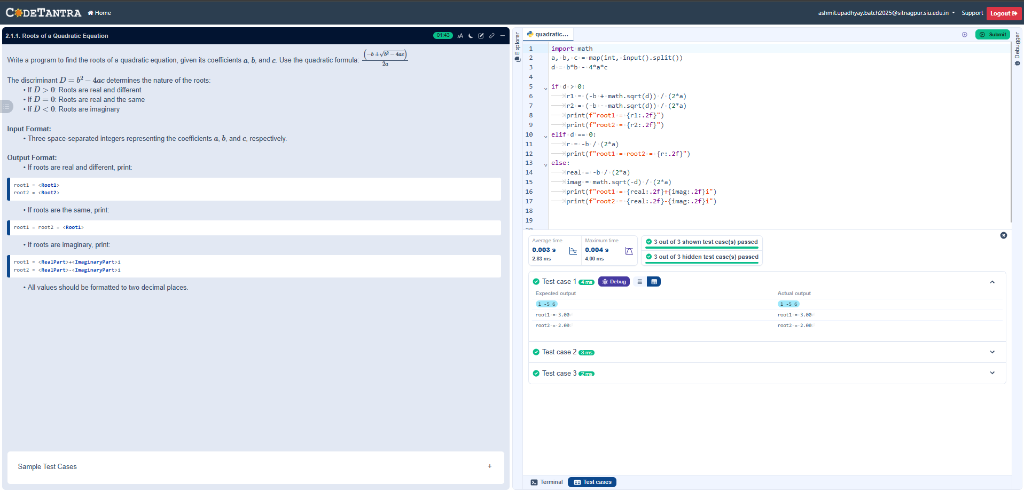

Experiment - 3.1.1. Largest of Three Numbers 1. Aim
BY-
NAME- ASHMIT UPADHYAY
SECTION – C1
PRN- 25070521129

2. Pseudocode
- START
- READ three integers a, b, and c from the user (one per line).
- INITIALIZE a variable largest to 0.
- IF a >= b AND a >= c: ○ Set largest = a.
- ELSE IF b >= a AND b >= c:
  - Set largest = b.
- ELSE:
  - Set largest = c.
- PRINT the value of largest.
- END

3. Flowchart
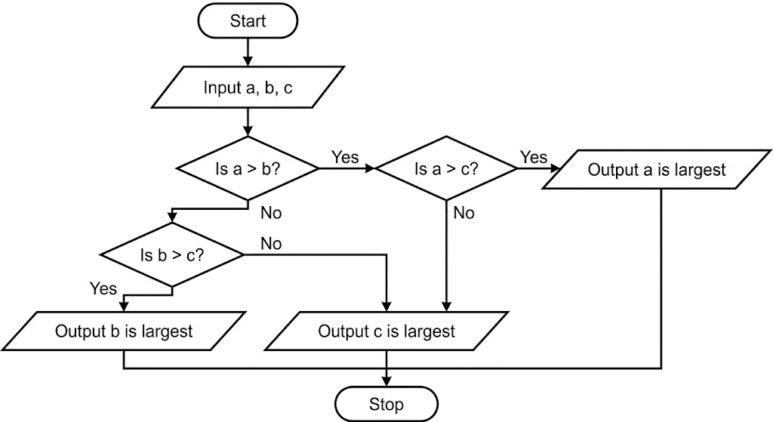

4. Python Program
# Program to find the largest of three integers
# Input: Three integers, one per line
# Output: The largest integer among the three

# Taking three integers as input
a = int(input("")) b = int(input(""))
c = int(input(""))

# Initializing variable to store the largest value largest = 0

# Comparative logic using logical 'and' if (a >= b) and (a >= c):
largest = a elif (b >= a) and (b >= c): largest = b else: largest = c

# Displaying the result print(largest)

5. Experiment Screenshot
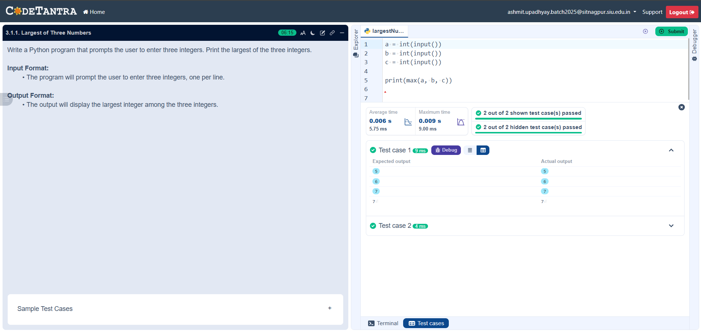

Experiment - 3.1.2. Celsius to Fahrenheit 1. Aim
BY-
NAME- ASHMIT UPADHYAY
SECTION – C1
PRN- 25070521129

2. Pseudocode
- START
- READ the input value as a float and store it in variable a (Celsius).
- CALCULATE the Fahrenheit value using the formula: b = a * (9/5) + 32.
- STORE the result in variable b.
- FORMAT the value of b to 2 decimal places.
- PRINT the formatted result.
- END

3. Flowchart
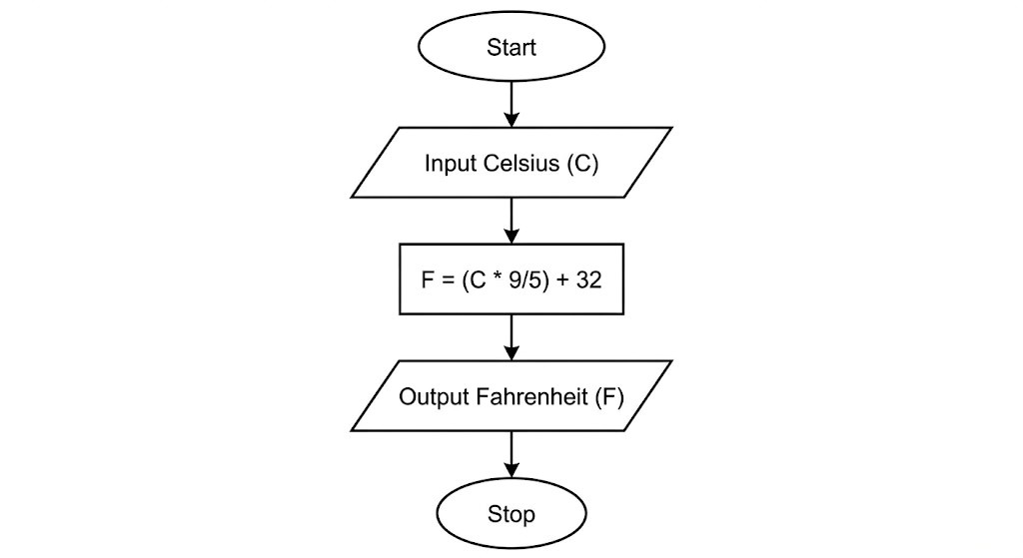

4. Python Program
# Program to convert Celsius to Fahrenheit
# Input: Celsius value as a float
# Output: Fahrenheit value formatted to 2 decimal places

# Taking Celsius input from the user
- = float(input(""))

# Applying the conversion formula
- = a * (9/5) + 32

# Displaying the result formatted to 2 decimal places print(f"{b:.2f}")

5. Experiment Screenshot
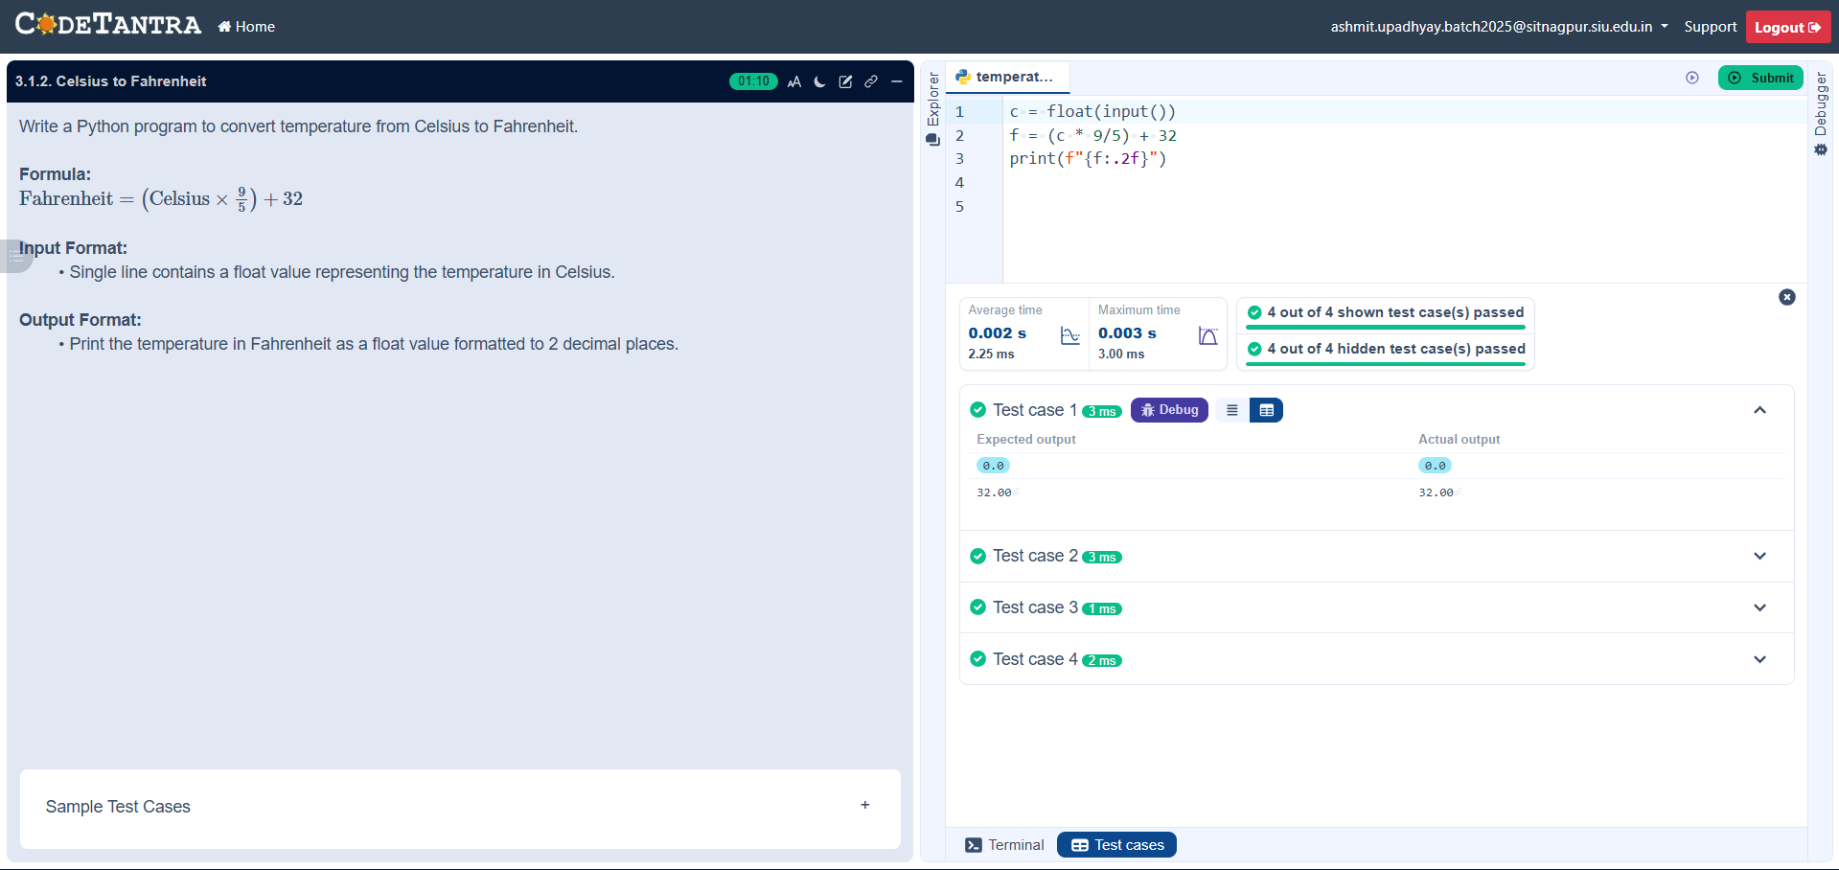

4.1.1. Set Operations
BY-
NAME- ASHMIT UPADHYAY
SECTION – C1

PRN- 25070521129

2. Pseudocode
- START
- PRINT the prompt "Set A: " and READ a line of space-separated integers.
- CONVERT the input values into a mathematical set and STORE it in the variable A.
- PRINT the prompt "Set B: " and READ a line of space-separated integers.
- CONVERT the input values into a mathematical set and STORE it in the variable B.
- CALCULATE the union of Set A and Set B (A | B) and STORE the result in union_set.
- CALCULATE the intersection of Set A and Set B (A & B) and STORE the result in intersection_set.
- CALCULATE the difference between Set A and Set B (A - B) and STORE the result in difference_set.
- PRINT the text "Union:" followed by the value of union_set.
- PRINT the text "Intersection:" followed by the value of intersection_set.
- PRINT the text "Difference:" followed by the value of difference_set.
- END

3. Flowchart
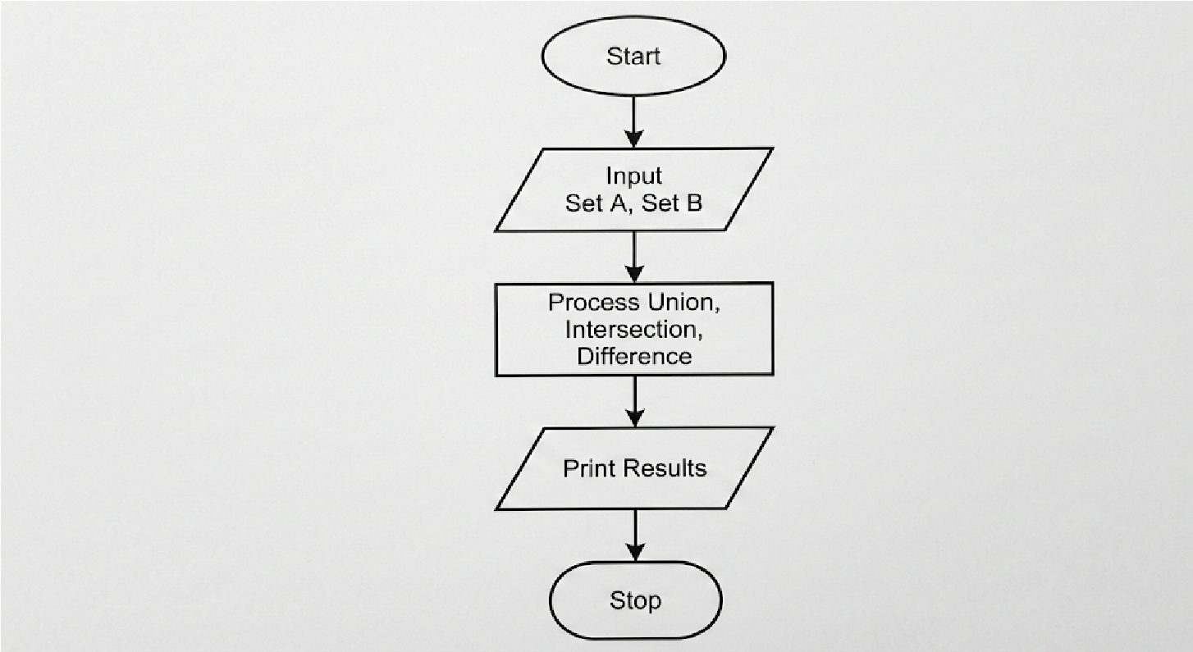

# Read sets
- = set(map(int, input("Set A: ").split()))
- = set(map(int, input("Set B: ").split()))

# Operations union_set = A | B intersection_set = A & B
difference_set = A - B

# Output
print("Union:", union_set) print("Intersection:", intersection_set)
print("Difference:", difference_set)

5. Experiment Screenshot

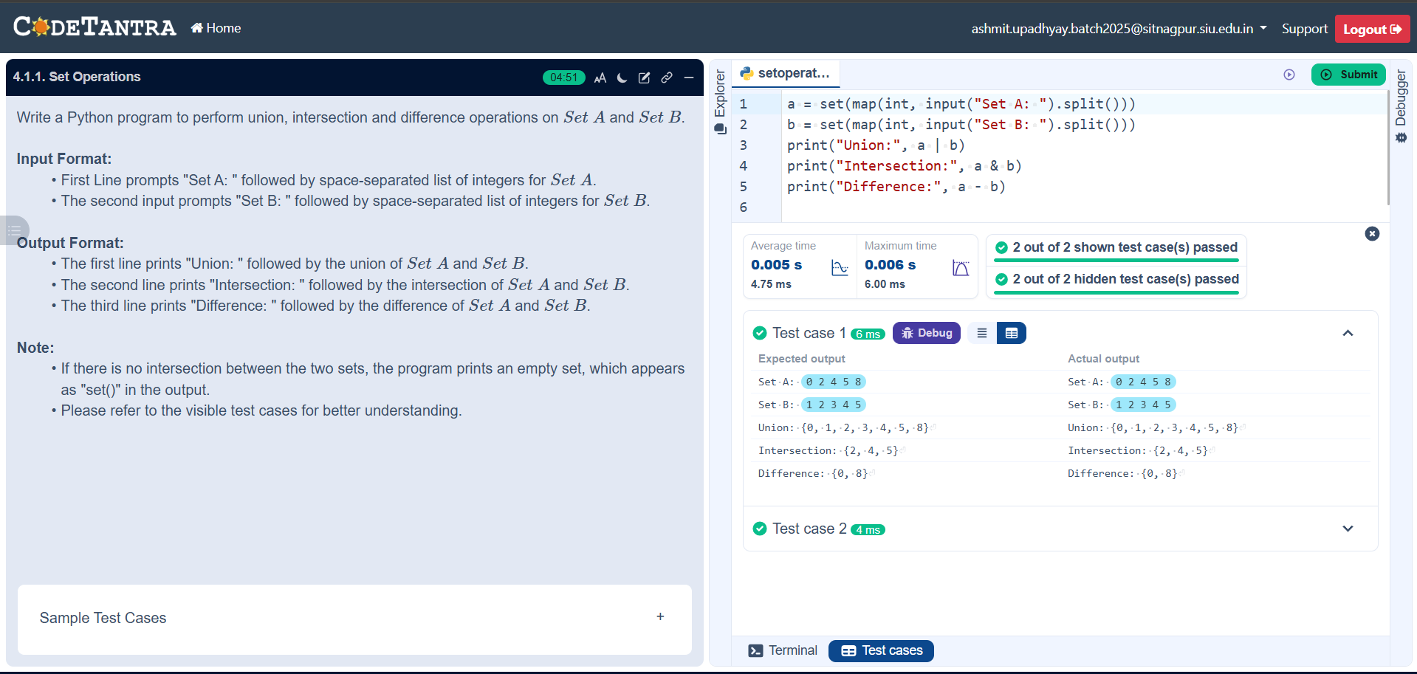

5.1.1. Leap Year Checker
BY-
NAME- ASHMIT UPADHYAY
SECTION – C1

PRN- 25070521129

2. Pseudocode
- START
- READ the input value from the user and convert it to an integer.
- STORE this value in the variable y.
- CHECK if the year y is divisible by 400 (y % 400 == 0).
○ OR check if the year y is divisible by 4 AND not divisible by 100 (y % 4 == 0 and y % 100 != 0).
- IF the condition in step 4 is True, PRINT "Leap year".
- ELSE, PRINT "Not a leap year".
- END

3. Flowchart
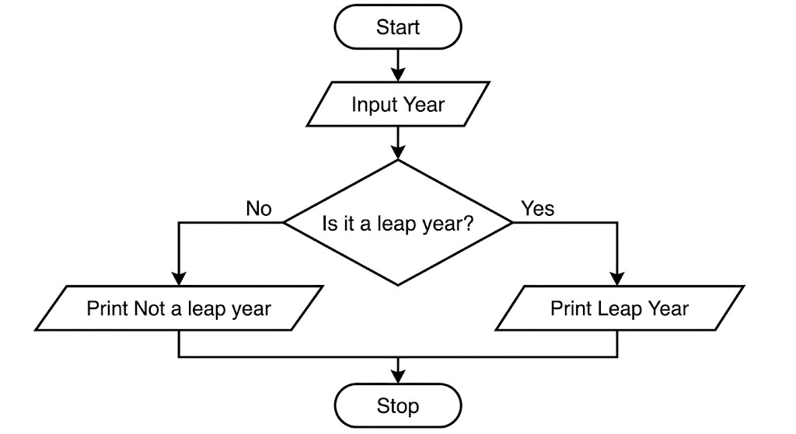

y = int(input())

if (y % 400 == 0) or (y % 4 == 0 and y % 100 != 0):
print("Leap year") else:
print("Not a leap year")

5. Experiment Screenshot

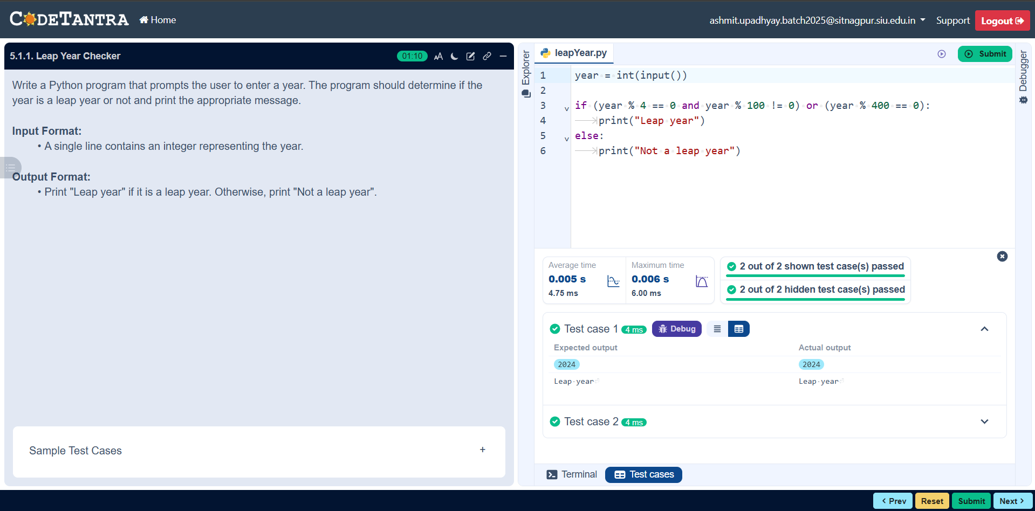

5.1.2. Student Grade Based
on Aggregate
BY-
NAME- ASHMIT UPADHYAY
SECTION – C1
PRN- 25070521129.

2. Pseudocode
- START
- READ four space-separated integers from the user and STORE them in variables m1, m2, m3, and m4.
- CALCULATE the sum of the four subjects and STORE it in the variable total (total = m1 + m2 + m3 + m4).
- CALCULATE the aggregate percentage by dividing the total by 4 and STORE it in the variable percentage.
- CHECK the value of percentage to determine the grade: ○ IF percentage > 75, STORE "Distinction" in grade.
○ ELSE IF percentage >= 60, STORE "First Division" in grade.
○ ELSE IF percentage >= 50, STORE "Second Division" in grade.
○ ELSE IF percentage >= 40, STORE "Third Division" in grade. ○ ELSE, STORE "Fail" in grade.
- PRINT the total marks.
- PRINT the percentage formatted to two decimal places.
- PRINT the grade.
- END

3. Flowchart
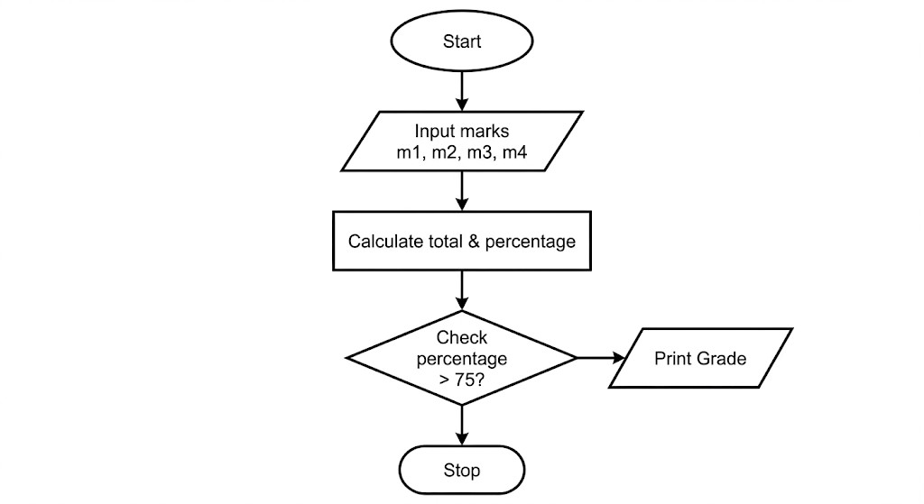
# Read four subject marks
m1, m2, m3, m4 = map(int, input().split())

# Calculate total and percentage total = m1 + m2 + m3 + m4
percentage = total / 4

# Determine the grade if percentage > 75:
grade = "Distinction" elif percentage >= 60: grade = "First Division" elif percentage >= 50:
grade = "Second Division" elif percentage >= 40: grade = "Third Division" else: grade = "Fail"

# Output the results print(total)
print(f"{percentage:.2f}") print(grade)

5. Experiment Screenshot

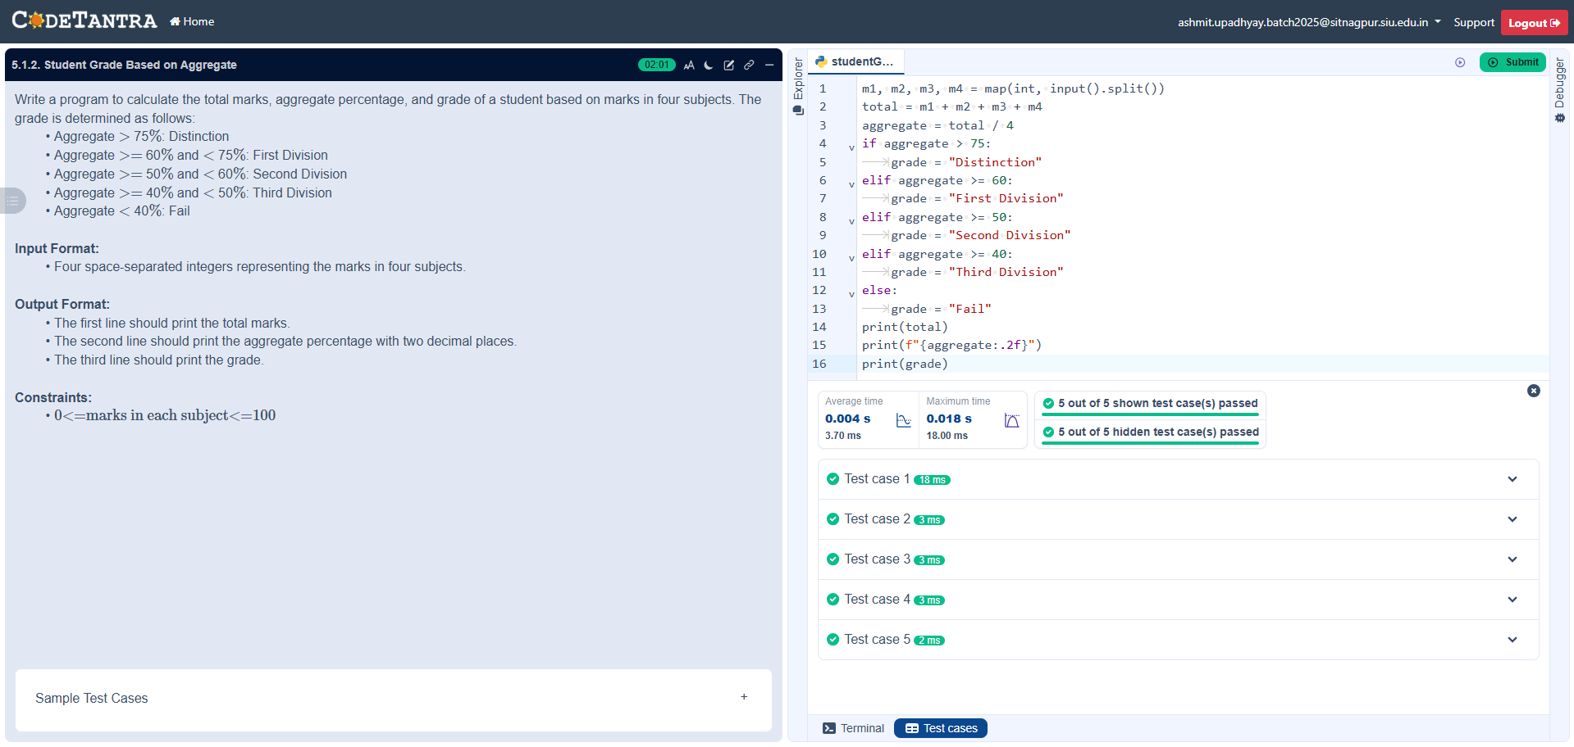

6.1.1. Incremented Date
BY-
NAME- ASHMIT UPADHYAY
SECTION – C1

PRN- 25070521129

2. Pseudocode
- START
- READ three integers from the user representing the day, month, and year, and STORE them in variables d, m, and y.
- INITIALIZE a boolean variable flag to True to keep track of date validity.
- CHECK basic validity: IF y <= 0 OR m < 1 OR m > 12, SET flag to False.
- IF flag is True:
  - DETERMINE maxdays based on the month:
■ IF m is 1, 3, 5, 7, 8, 10, or 12: maxdays = 31.
■ ELSE IF m is 4, 6, 9, or 11: maxdays = 30.
■ ELSE IF m is 2 (February):
■ IF the year y is a leap year ((y % 400 == 0) or (y % 4 == 0 and y % 100 != 0)): maxdays = 29.
■ ELSE: maxdays = 28.
○ CHECK day validity: IF d < 1 OR d > maxdays, SET flag to False.
- IF flag is True (The date is completely valid): ○ INCREMENT the day d by 1.
  - IF d > maxdays (End of the month reached):
■ SET d = 1.
■ INCREMENT the month m by 1.
■ IF m > 12 (End of the year reached):
■ SET m = 1.
■ INCREMENT the year y by 1.
○ PRINT the incremented date formatted as DD-MM-YYYY (zero-padded).
- ELSE:
  - PRINT "Invalid Date".
- END

3. Flowchart

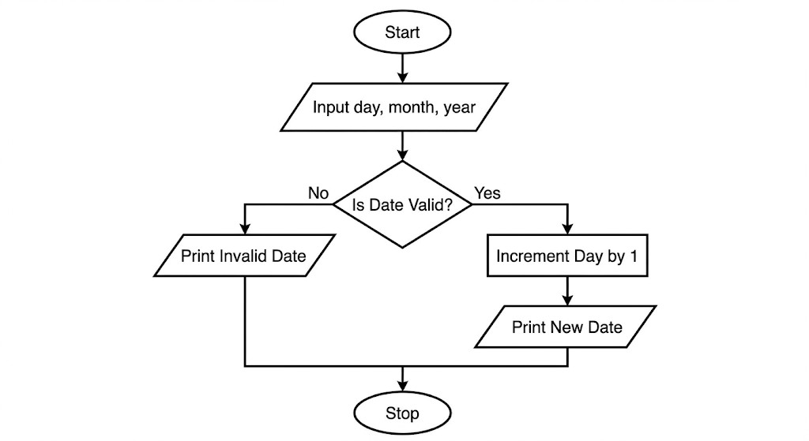

4. Python Program
d = int(input())
m = int(input())
y = int(input())

flag = True
maxdays = 0

# Check valid year and month bounds if y <= 0 or m < 1 or m > 12:
flag = False

# Determine maximum days in the given month if year and month are valid if flag: if m in (1, 3, 5, 7, 8, 10, 12):
maxdays = 31 elif m in (4, 6, 9, 11): maxdays = 30 elif m == 2:
# Leap year check if (y % 400 == 0) or (y % 4 == 0 and y % 100 != 0):
maxdays = 29 else:
maxdays = 28

# Check if the day is within the valid range for the month if d < 1 or d > maxdays:
flag = False

# Increment date or print invalid message if flag: d += 1
# Check if we need to roll over to the next month if d > maxdays:
d = 1 m += 1
# Check if we need to roll over to the next year if m > 12: m = 1
y += 1

# Print in zero-padded DD-MM-YYYY format
print(f"{d:02d}-{m:02d}-{y:04d}") else: print("Invalid Date")

5. Experiment Screenshot
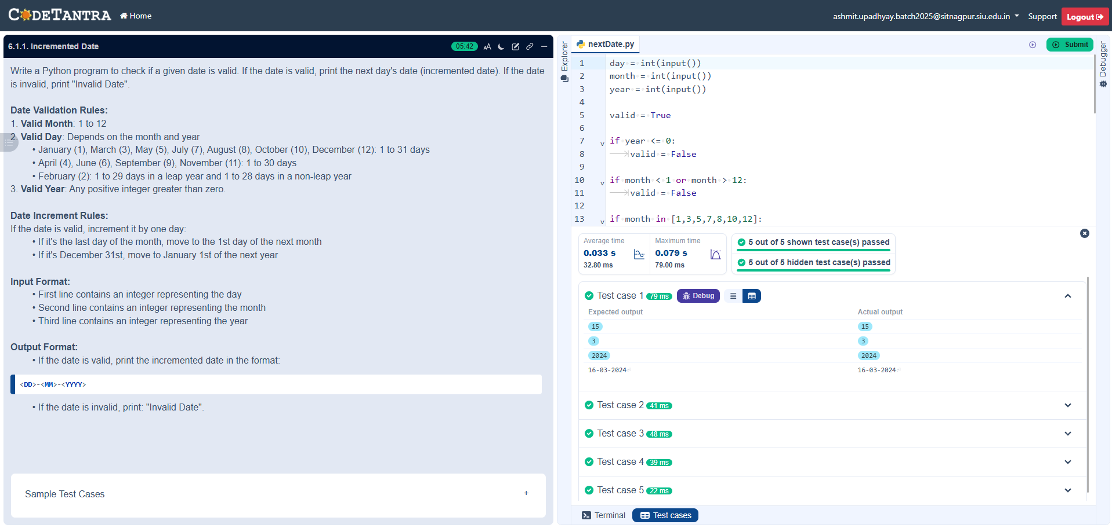

6.1.2. Factorial of a Number
BY-
NAME- ASHMIT UPADHYAY
SECTION – C1

PRN- 25070521129

2. Pseudocode
- START
- READ a single integer from the user and STORE it in the variable n.
- INITIALIZE a variable factorial to 1.
- FOR each number i in the range from 1 to n (inclusive): ○ MULTIPLY factorial by i (factorial = factorial * i). ○ STORE the new value back into factorial.
- END FOR loop once all numbers up to n have been multiplied.
- PRINT the final value of factorial.
- END

3. Flowchart
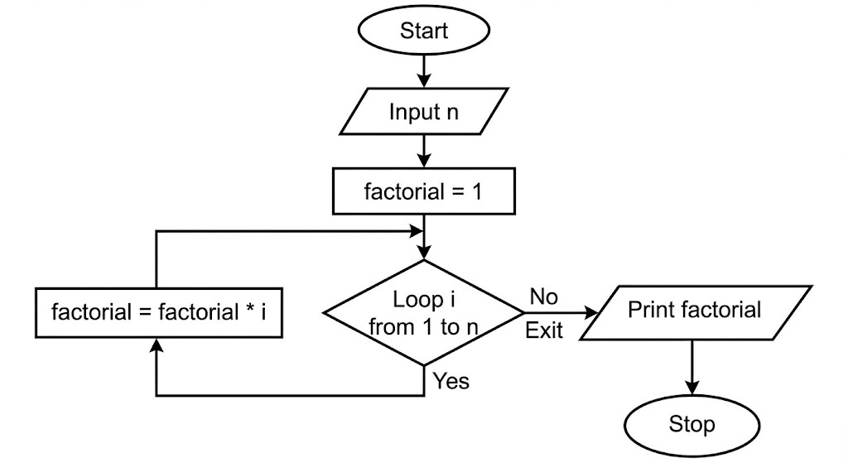

4. Python Program
n = int(input())

factorial = 1

for i in range(1, n + 1): factorial *= i

print(factorial)

5. Experiment Screenshot

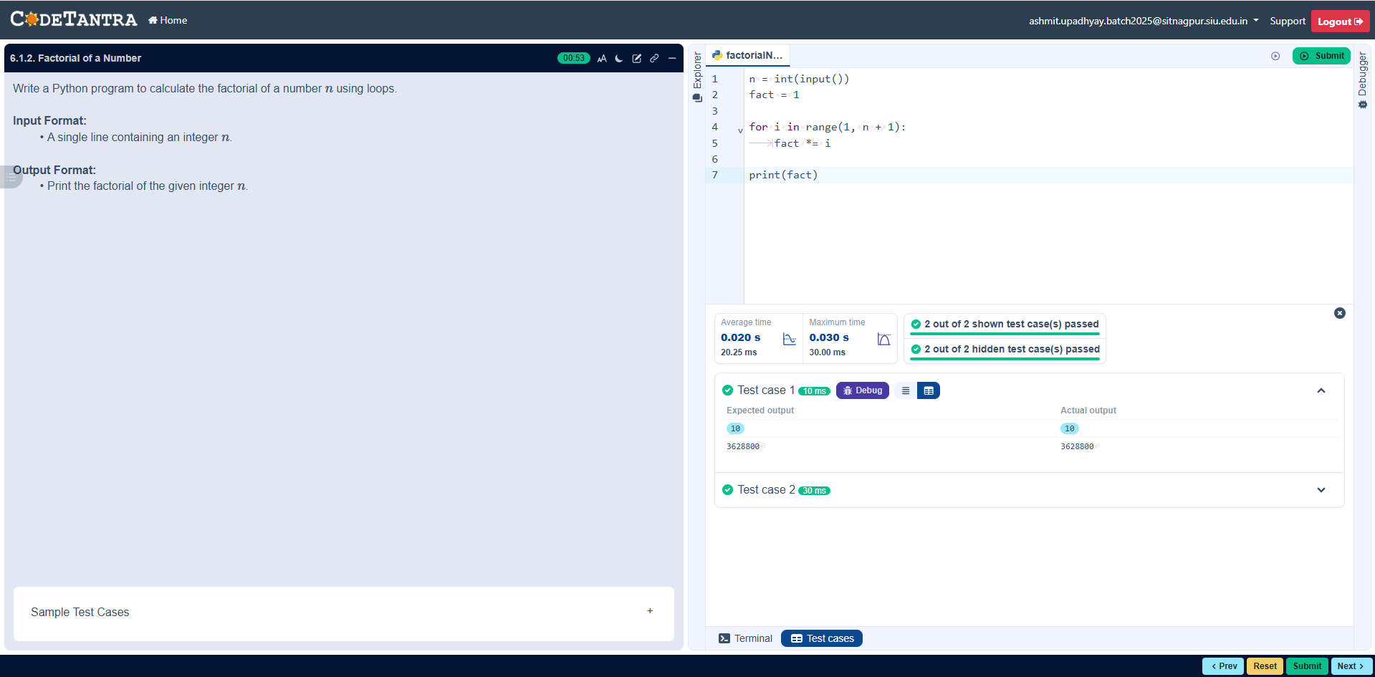

7.1.1. Inverted Star Pattern
BY-
NAME- ASHMIT UPADHYAY
SECTION – C1
PRN- 25070521129

2. Pseudocode
- START
- READ a single integer from the user and STORE it in the variable n.
- FOR each number i in the range starting from n down to 1 (decrementing by 1):
○ FOR each number j in the range from 0 to i - 1:
■ PRINT a star "*" without a newline character at the end.
○ END INNER FOR
○ PRINT an empty line (newline character) to move to the next row.
- END OUTER FOR
- END

3. Flowchart
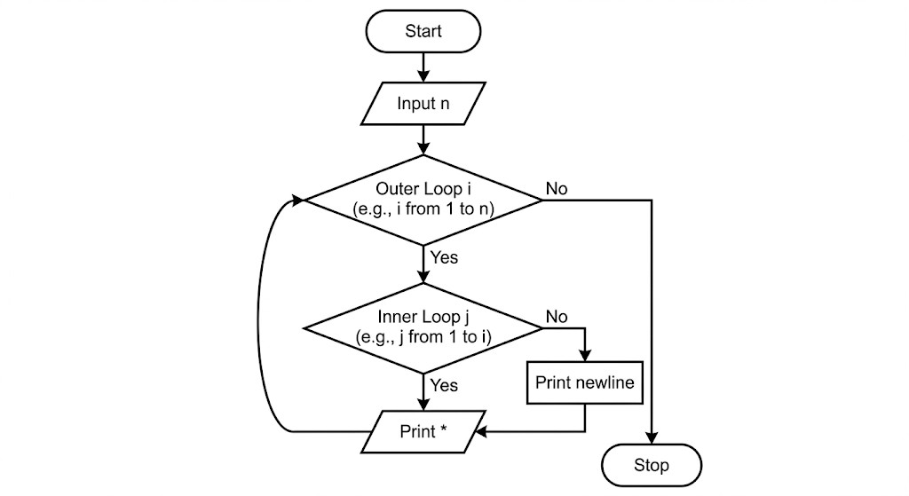

4. Python Program
n = int(input())

for i in range(n, 0, -1): for j in range(i):
print("*", end="") print()

5. Experiment Screenshot
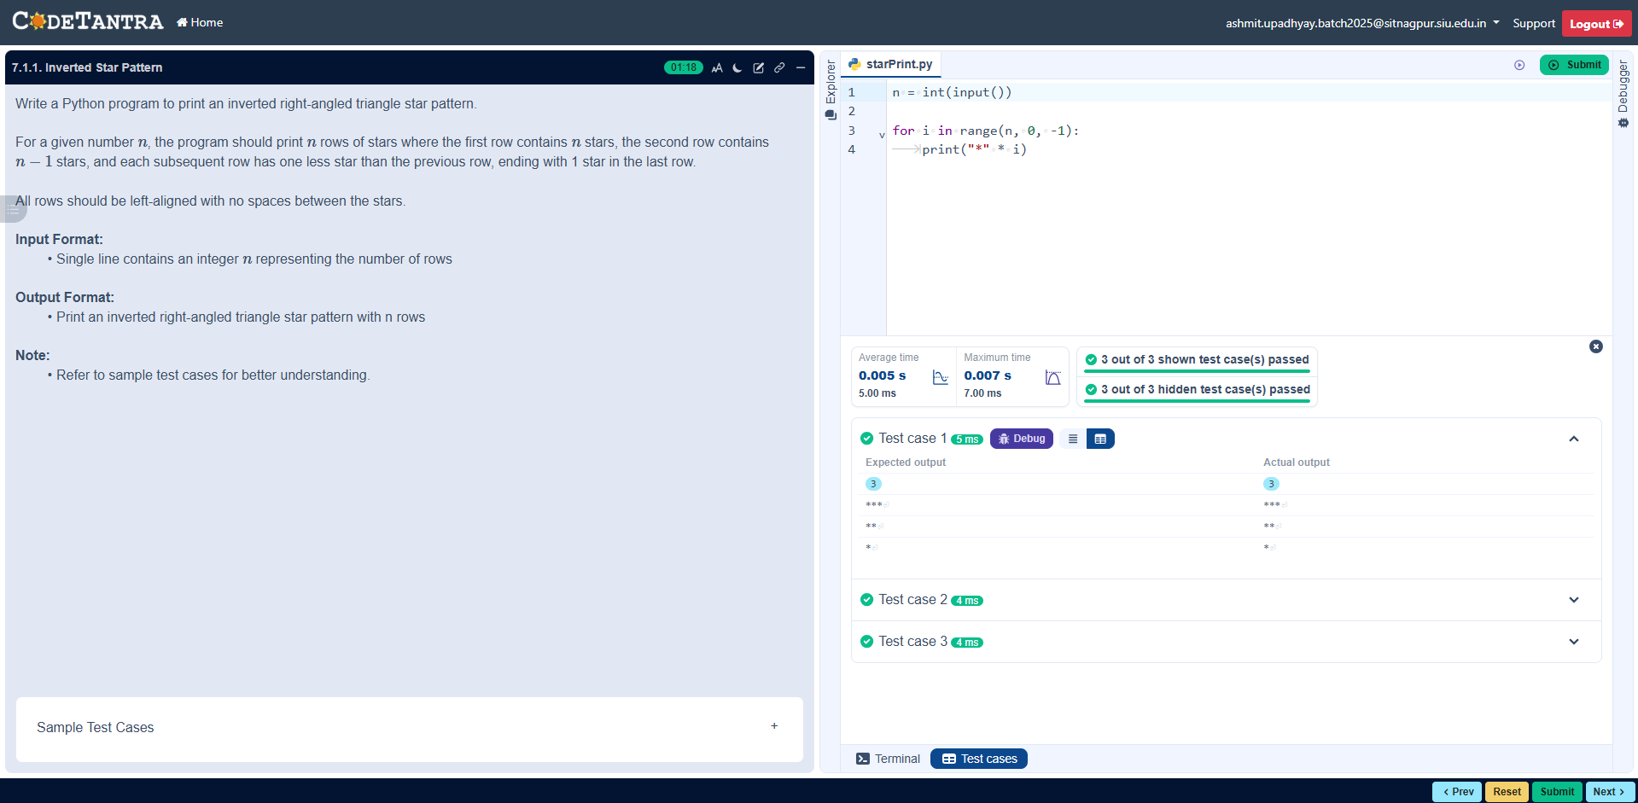

7.1.2. Possible Combinations from Three Digits
BY-
NAME- ASHMIT UPADHYAY
SECTION – C1
PRN- 25070521129

2. Pseudocode
- START
- READ a single line of input from the user, split it by spaces, and STORE the three string values into variables a, b, and c.
- PRINT the concatenation of a, b, and c (representing the combination ). 4. PRINT the concatenation of a, c, and b (representing the combination ). 5. PRINT the concatenation of b, a, and c (representing the combination ).
6. PRINT the concatenation of b, c, and a (representing the combination ). 7. PRINT the concatenation of c, a, and b (representing the combination ).
- PRINT the concatenation of c, b, and a (representing the combination ).
- END

3. Flowchart
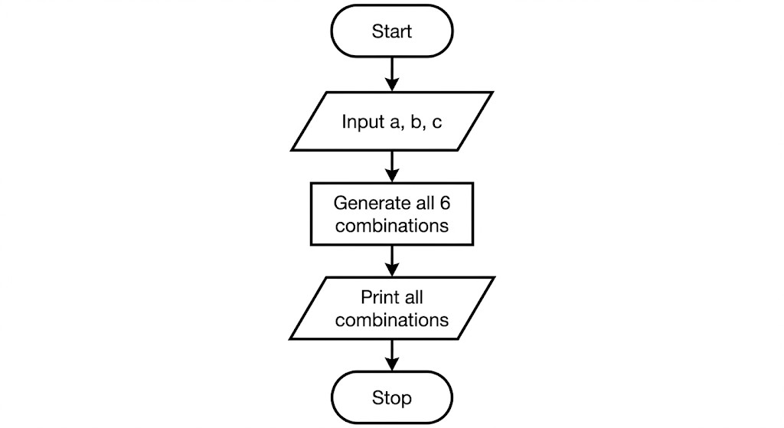

4. Python Program
a, b, c = input().split()

print(a + b + c) print(a + c + b) print(b + a + c) print(b + c + a) print(c + a + b) print(c + b + a)

5. Experiment Screenshot
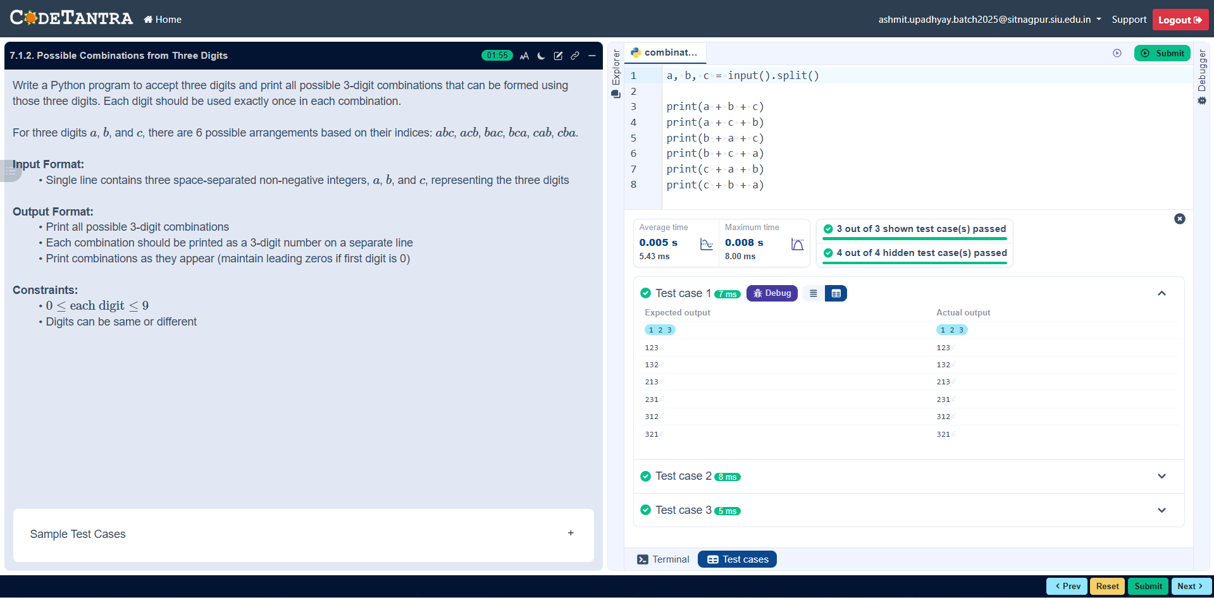

8.1.1. Multiplication of Two Square Matrices
BY-
NAME- ASHMIT UPADHYAY
SECTION – C1
PRN- 25070521129

2. Pseudocode
- START
- PRINT "dimension: " and READ an integer from the user, storing it in the variable n.
- PRINT "first matrix:" and INITIALIZE an empty list A.
- FOR each row i from 0 to n-1:
  - READ space-separated integers from the user, convert them into a list, and append to A.
- PRINT "second matrix:" and INITIALIZE an empty list B.
- FOR each row i from 0 to n-1:
  - READ space-separated integers from the user, convert them into a list, and append to
B.
- INITIALIZE a result matrix of size filled with zeros.
- FOR i in range n (iterating through rows of A):
  - FOR j in range n (iterating through columns of B):
■ FOR k in range n (iterating through rows of B):
■ ADD the product of A[i][k] and B[k][j] to result[i][j].
- PRINT "Resultant Matrix:".
- FOR each row r in the result matrix:
  - PRINT the elements of r separated by spaces.
- END

3. Flowchart
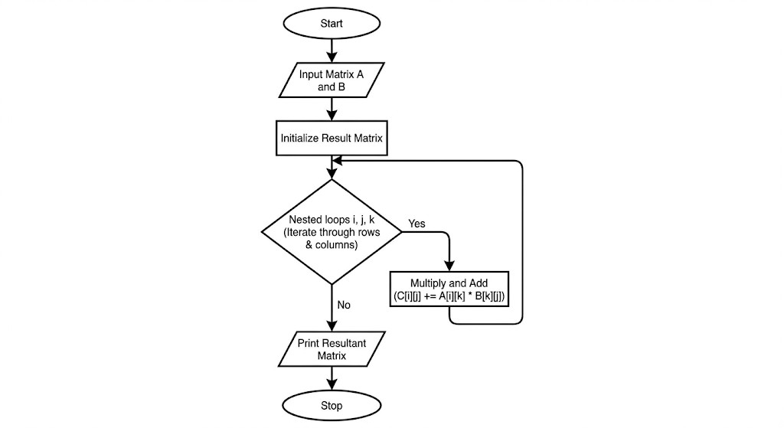

4. Python Program
n = int(input("dimension: "))

print("first matrix:") A = [] for i in range(n):
A.append(list(map(int, input().split())))

print("second matrix:") B = [] for i in range(n):
B.append(list(map(int, input().split())))

result = [[0]*n for _ in range(n)]

# Matrix multiplication logic for i in range(n): for j in range(n): for k in range(n): result[i][j] += A[i][k] * B[k][j]

print("Resultant Matrix:") for r in result: print(*(r))

5. Experiment Screenshot
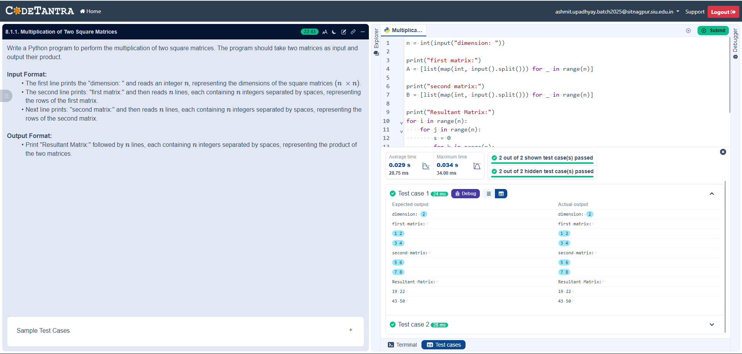

8.1.2. Prime Numbers in a Given Range

BY-
NAME- ASHMIT UPADHYAY
SECTION – C1
PRN- 25070521129

2. Pseudocode
- START
- READ an integer representing the start of the range and STORE it in start.
- READ an integer representing the end of the range and STORE it in end.
- INITIALIZE a boolean variable found to False to keep track of whether any primes exist.
- FOR each number num in the range from start to end (inclusive):
  - IF num > 1 (since 1 and numbers below it are not prime):
■ INITIALIZE is_prime to True.
■ FOR each number i from 2 up to the integer square root of num (int(num**0.5) +
1):
■ IF num is divisible by i (num % i == 0):
■ SET is_prime to False.
■ BREAK the inner loop.
■ IF is_prime is True:
■ PRINT the prime number num. ■ SET found to True.
- IF found is False (meaning no primes were printed):
  - PRINT "No primes".
- END

3. Flowchart
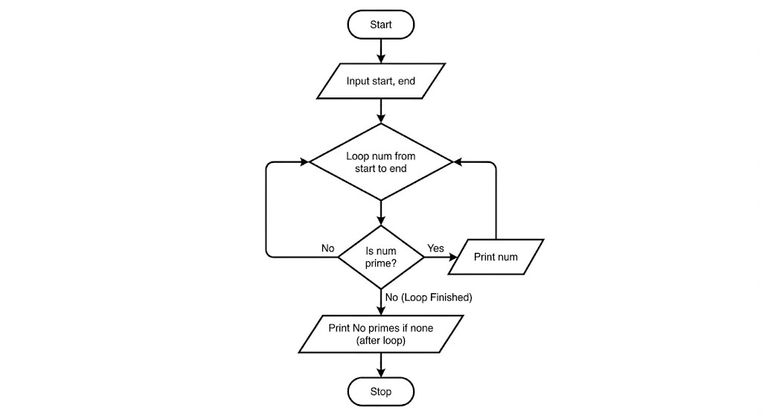

4. Python Program
start = int(input())
end = int(input())

found = False

for num in range(start, end + 1): if num > 1:
is_prime = True for i in range(2, int(num**0.5) + 1): if num % i == 0: is_prime = False
break

if is_prime: print(num)
found = True

if not found:
print("No primes")

5. Experiment Screenshot

